**BUG FINDING**

**Bug report -01**

1. **Title** : On the name option and number option you can write so many word and number but not showing any error message
2. **Description** : On the log in page when you are writing on name place so many latter and number place so many number in that time not showing any error message.
3. **Priority**: priority is high.
4. **Severity** : it also high
5. **Steps** :
6. Click on the application
7. The it should go to the log in page
8. Write name and mobile number
9. Verify it
10. **Expected** **result** : on the name option and number option should be write valid name and number
11. **Actual** **Result** : but in this application on the name and number option you can write so many number and word.
12. **Tested** **device**: vivo z1 pro
13. **Tested** **os** :android 10
14. **Attachment:**

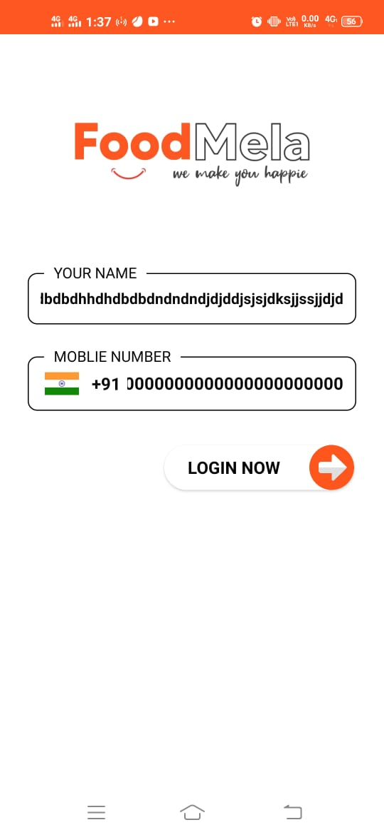

**Bug report-02**

1. **Title** : write wrong name and mobile number but it go to the verify the code page
2. **Description** :when you write wrong name and number then if you click log in option, it will be go to the verify page with out showing any error massage
3. **Priority** : should be high
4. **Severity** : its medium
5. **Steps** :
6. Click on the application
7. Write name and mobile number
8. Click on log in option
9. Verify it
10. **Expected** **Result**: when you click log in option that time should be show the wrong message
11. **Actual** **Result** : but it does not shows any error massage
12. **Tested** **Device**: vivo z1 pro
13. **Tested** **os** :android 10
14. **Attachment**:

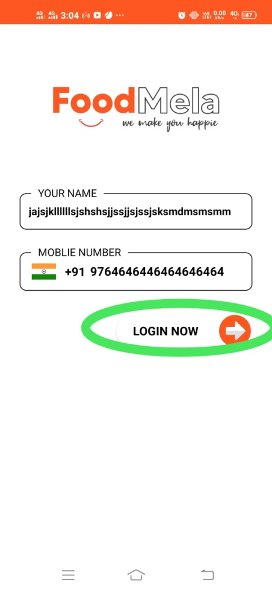 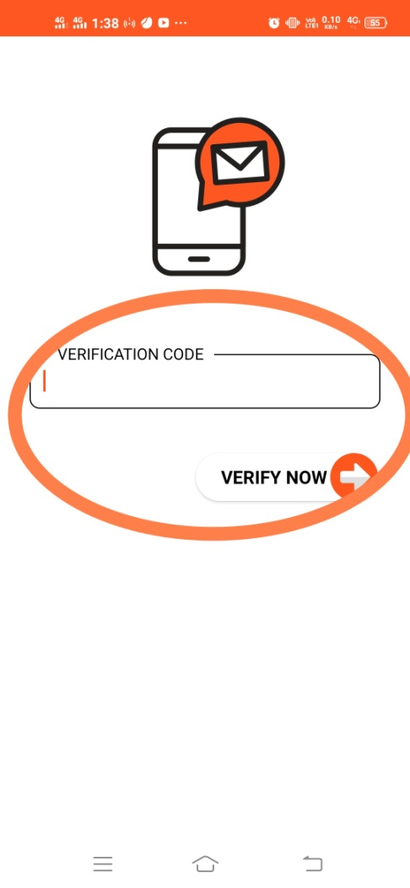

Bug report-03

1. **Title** : when you are going to pay now page if you select wrong address and wrong number then also your order place .
2. **Description** : select wrong area and write wrong number but on the pay now page then also order place successfully not showing any error massege.
3. **Priority** : it should be high
4. **Severity** :it is also high
5. **Steps** :
6. Click on the application > log in the application>go to the home page
7. Add to cart
8. Then go to the pay now page
9. Select area, name , mobile number ,
10. Verify it
11. **Expected** **result** : when you select wrong area and wrong mobile number that time should show error massage.
12. **Actual** **result** : but in this application does not showing any error message
13. **Tested** **device**: vivo z1 pro
14. **Tested** **os** :android 10
15. **Attachment**

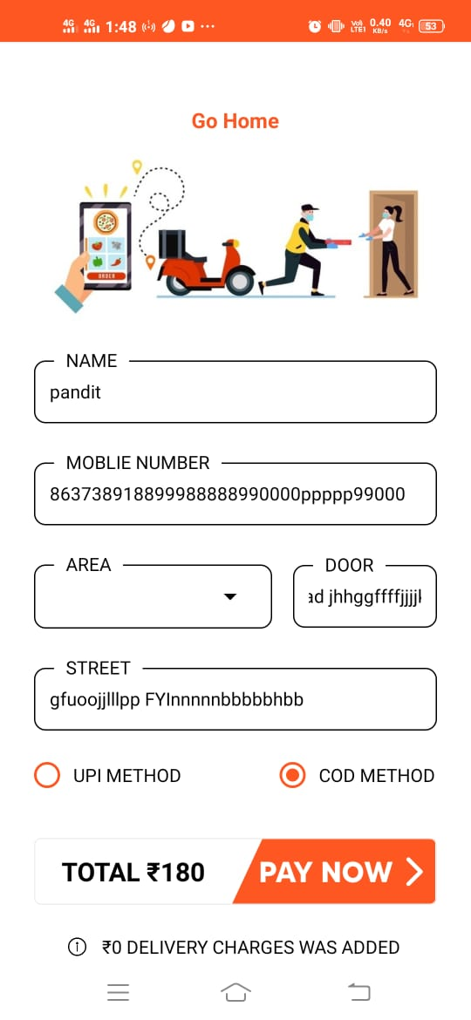 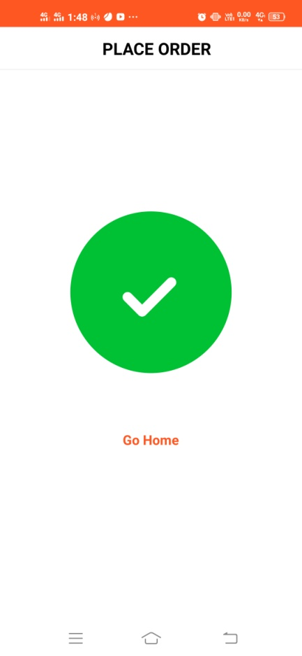

**Bug report-04**

1. Title : off internet and add to cart anything you can add successfully
2. Description : if you click add to cart anything off mobile internet then you should add successfully without any error message
3. Priority : high
4. Severity: high
5. Steps:
6. Click on the application
7. Go to home page
8. Off the mobile internet
9. Click on add to cart option
10. And verify
11. Expected result: when you off your mobile internet that time should not add cart any product
12. Actual result : it is easily add when you click add to cart and shows on the my cart page.
13. Tested os :android 10
14. Tested device: vivo z1 pro
15. Attachment:

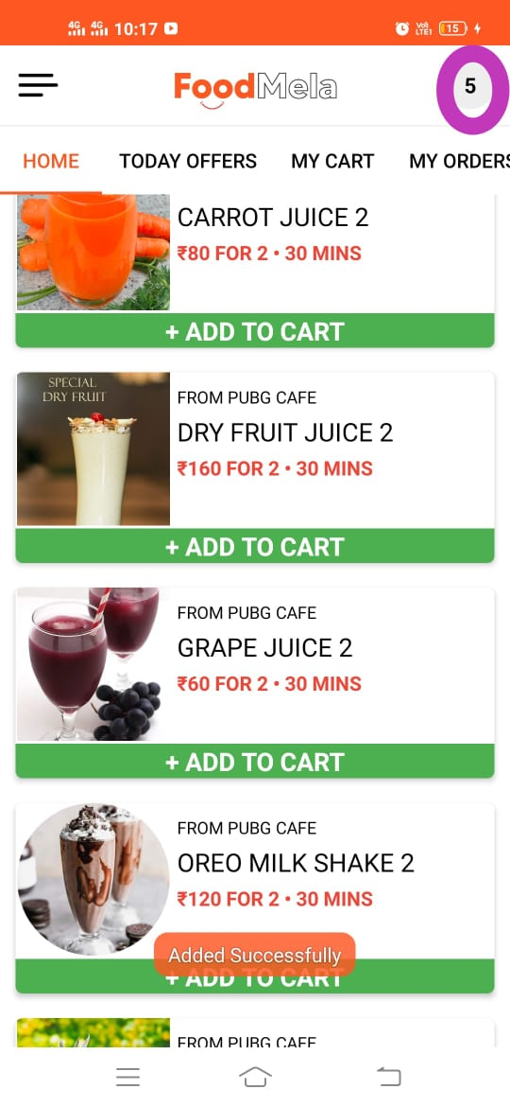 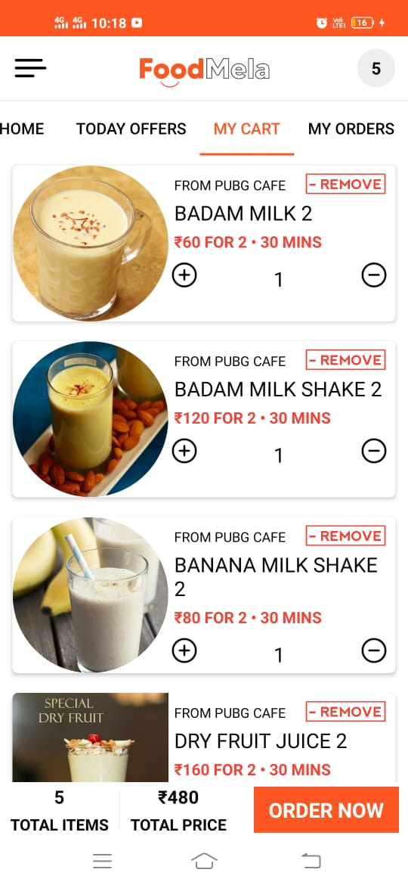

**Bug Report-05**

1. **Title**: if you click log out option then you are go to outside from the profile page.
2. **Description**: click on three parallel line and go to the profile page then click on log out option and see that you can exit directly from the outside of application.
3. **Priority** : it should be high
4. Severity: medium
5. **Steps** :
6. Click on the application
7. Log in the application with mobile number
8. Go to home page > click on three parallel line > open profile page
9. Click on log out option
10. Verify
11. **Expected result:** when you click log out option then it should go to the log in page .
12. **Actual result**: but in this application when you click log out option then you are directly go outside from the application
13. **Tested os:** android 10
14. **Tested** **device** : vivo z1 pro
15. **Attachment** : https://drive.google.com/file/d/1eU-RVkA9Ol37NRY92RGckiJrhQ-mf-6A/view?usp=drivesdk

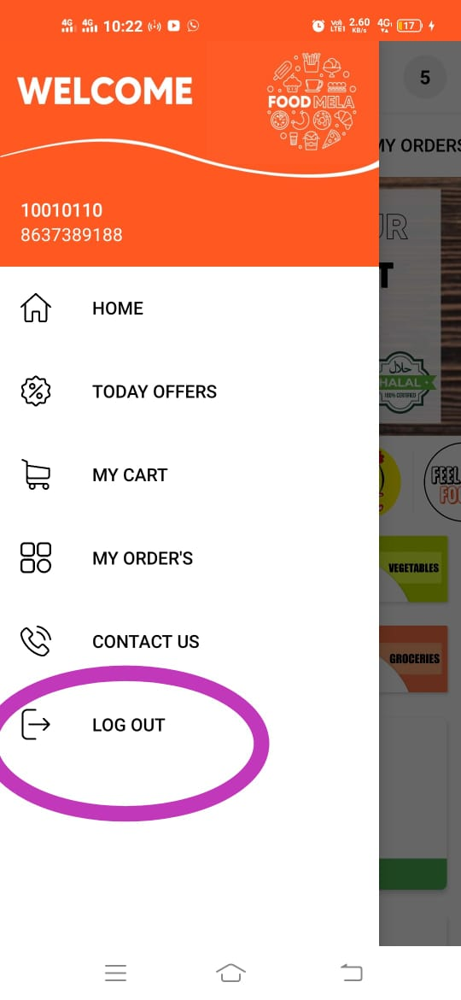

**Bug report -06**

1. **Title**: click back symbol on the home page then on the screen shows “press back again to exit”.
2. **Description**: if you click back symbol to exit from the application but on the home page screen shows “press back again to exit” if you press back three or four time then it back to the out outside.
3. **Priority** : medium
4. **Severity**: high
5. **Steps** :
6. Click on the application
7. Log in with mobile number >go to the home page
8. Press back symbol
9. Verify
10. **Expected** **result**: if you press one time back symbol then you should come to outside of application
11. **Actual** **result** :in this app if you press one or two time then it shows “press back again to exit”
12. **Tested** **os** : android 10
13. **Tested** **device**: vivo z1pro
14. **Attachment** :

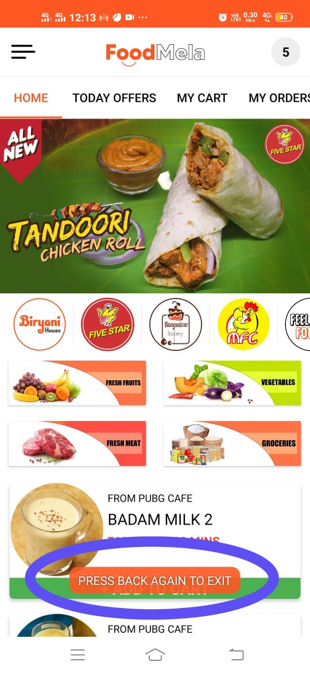

**Bug report-07**

1. **Title**: open my order page see there is no cancel option and tracking options but showing order on the order page.
2. **Description**: if you want to cancel or tracking your order then it not possible for this application because on the order page have not any cancel or tracking option.
3. **Priority** : medium
4. **Severity** : medium
5. **Steps** :
6. Click on the application
7. Log in the application with mobile number
8. Select any product> add to cart > order the product
9. Open the order page for cancel or tracking product
10. Verify
11. **Expected result**: if you open the order page in there should have cancel and tracking option.
12. **Actual result** : in this application on the order page have not cancel and tracking option .
13. **Tested os**: android 10
14. **Tested device:** vivo z1 pro
15. **Attachment** :

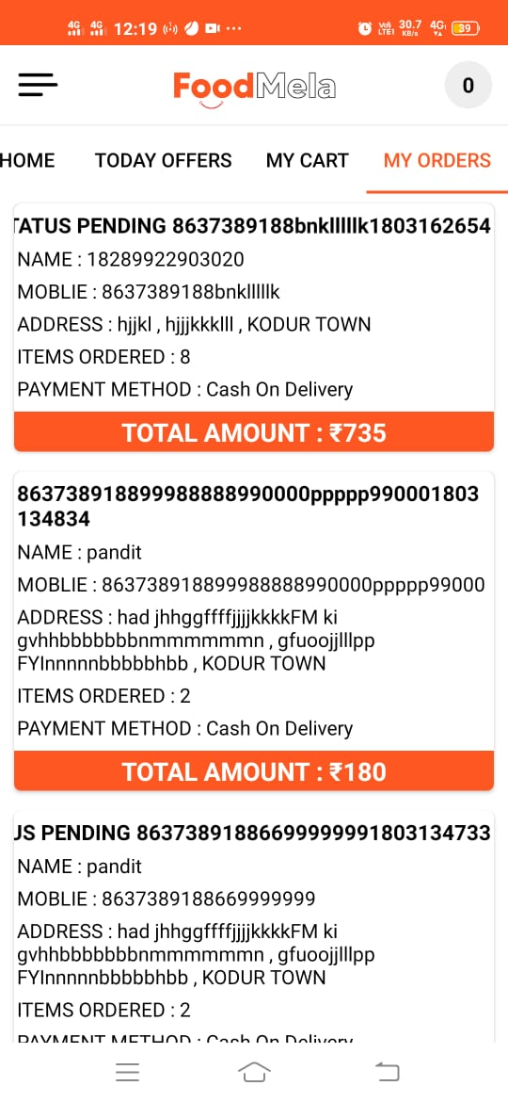

**Bug report-08**

1. **Title**: On the my cart page is not any added product but still there is order now option .
2. **Description** : I don’t add any product but when I open the my cart page that time shows the order now option .
3. **Priority** :medium
4. **Severity** : medium
5. **Steps** :
6. Click on application
7. Log in the application with mobile number
8. Open my cart page
9. Verify
10. **Expected result**: when I don’t add any product then on my cart page should not show order now option.
11. **Actual result** : without adding any product the my cart page shows the order now option
12. **Tested os**: android 10
13. **Tested device** : vivo z1 pro
14. **Attachment** :

